Circuit Analysis (Lab10)

Experiment 9: Verification of Thevenin’s Theorem

Name: Muhammad Zia Ur Rehman Zahid Registration No: 2025-CE-104
Date: 11-May-2026 Grade and Signature: ……………………
CLO2 CLO3 | Use with identification the circuit components, breadboards, multimeter, power supplies, signal generators, and oscilloscopes. Make measurements in their own constructed electric circuits.
Psychomotor/Affective | Level1  (1) | Level2 (2-3) | Level3 (4-5) | Level4 (6-7)
Report Marks (3)
 | Total marks (10)

Objective
The objective of this lab is verify Thevenin’s theorem and to find the full load current.

Apparatus Required
Sr. no | Apparatus | Range | Quantity
1 | Regulated Power Supply | Standard | 1
2 | Signal Generator | Standard | 1
3 | Oscilloscope | Standard | 1
4 | Digital Multimeter | Standard | 1
5 | Breadboard & Wires | Standard | As Required
6 | Resistors | 1k, 330 ohms | 1,3
7 | Potentiometer | Standard | 1

Description

Statement:
Any linear bilateral, active two terminal network can be replaced by an equivalent voltage source (VTH). Thevenin’s voltage or V OC in series with looking pack resistance RTH.

Precautions:
- Voltage control knob of RPS should be kept at minimum position.
- Current control knob of RPS should be kept at maximum position

Procedure:
- Connections are given as per the circuit diagram.
- Set a particular value of voltage using RPS and note down the corresponding ammeter readings. To find VTH 3. Remove the load resistance and measure the open circuit voltage using multimeter (VTH). To find RTH
- To find the Thevenin’s resistance, remove the RPS and short circuit it and find the RTH using multimeter.
- Give the connections for equivalent circuit and set VTH and RTH and note the corresponding ammeter reading. 6. Verify Thevenins theorem.

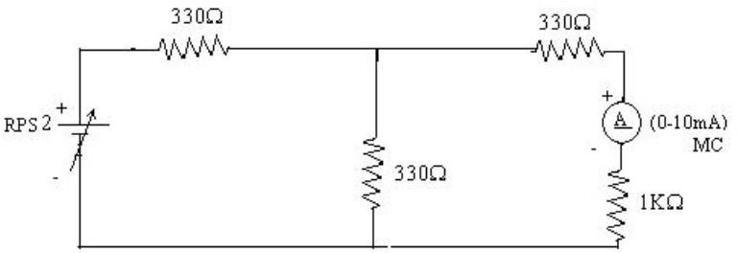
Circuit - 1: To find load current

To find VTH
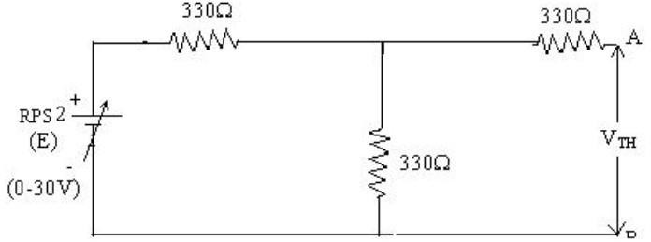

To find RTH
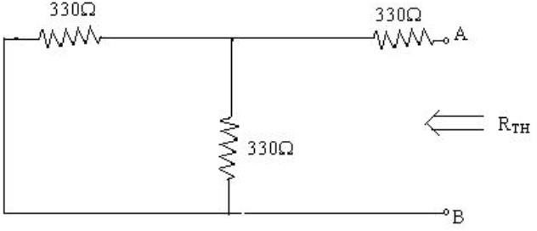

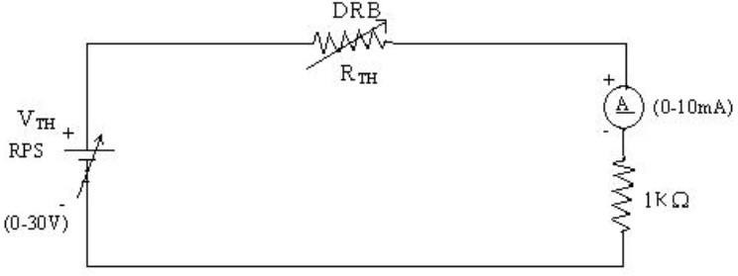
Thevenin’s Equivalent circuit:

Thevenin Practical Values

 | E(V) | VTH(V) | RTH(ohms) | IL (mA)
 |  |  |  | Circuit - I | Equivalent Circuit
Values | 15V | 7.5V | 496 | 5.02mA | 5.02mA

Post Lab Questions

What is Thevenin’s Theorem?
Thevenin’s Theorem states that any linear, bilateral network containing multiple voltage sources and resistances can be replaced by a single equivalent circuit. This equivalent consists of a single voltage source, Vth (Thevenin Voltage), in series with a single resistor, Rth (Thevenin Resistance), connected across the load. It simplifies complex circuits, making it much easier to calculate the current or voltage across a specific component without re-analyzing the entire system.

What are the applications of Thevenin’s Theorem?
• Circuit Simplification: It is primarily used to reduce complex networks into a simple series circuit for faster analysis.
• Load Analysis: It is ideal for circuits where the load resistance (RL) changes frequently, as you only need to calculate the equivalent once.
• Power Optimization: It helps in calculating the Maximum Power Transfer to a load by easily matching RL to Rth.
• Electronic Design: Engineers use it to model the output characteristics of power supplies and sensory interfaces.

What are the theoretical and practical limitations of Thevenin’s Theorem?
• Linearity Requirement: The theorem only applies to linear components; it cannot be used for circuits with non-linear elements like diodes or transistors (unless analyzed in a small-signal linear range).
• Bilateral Limitation: It is only applicable to bilateral networks where the properties don't change with the direction of current.
• Dependent Sources: While it works with dependent sources, the calculation becomes significantly more complex as you cannot simply "turn them off" to find Rth.
• Efficiency Data Loss: While the load calculations remain accurate, the internal power consumption and efficiency of the original circuit cannot be determined from the Thevenin equivalent alone.

